Project 1: Final Cloud Migration Plan
Matthew Santiago
University of Maryland Global Campus
CCS 640 Cloud Computing Implementations and Migrations
Charlie Shao
April 21, 2025

Executive Summary
As we continue to plan to move the on premise servers into the cloud, we are submitting the final cloud migration plan for approval. This migration into the cloud will enable BallotOnline to achieve better scalability, lower operational costs and improved service reliability. In accordance with AWS best practices we have put together this document to develop a clear understanding and communicate this understanding to BallotOnline employees broadly (Amazon Web Services, 2016). In this cloud migration plan we will walk through a planned transfer of servers and data to Amazon Web Services cloud. The plan will describe pre-migration considerations, migration tools like AWS Application Discovery Service, NetApp OnCommand Insight and Azure Migrate, the analysis of data collected from our servers and lastly, migration recommendations.
Scope
Overview
The scope of this migration plan includes on premise servers that host web applications and databases. The main objective is to move the Apache HTTP server, MySQL database and PHP applications to AWS. The migration will not include systems that are non-essential to the goals of BallotOnline. The migration will move our applications from the data center into the cloud without making any changes to the application (Amazon Web Services, 2025).
Cloud Migration Prerequisites
- Inventory: Using AWS Application Discovery Service to find data center servers for migration.
- Network: Use AWS Direct Connect for data transfer.
- Approval: Alignment with BallotOnline IT policies and executive approval for migration strategy.
- Staff: Train employees on AWS cloud services and AWS management.
- Backup: ensure backups are available to make sure data is safe during migration.

Cloud Pre-migrations Considerations
Before beginning there are a couple factors that need to be looked at before BallotOnline can begin moving our on-premises servers to AWS cloud infrastructure. The first factor is data security, where we need to ensure that data is secure in transit. This will be done through the use of AWS Direct Connect which establishes "dedicated network connection to AWS in order to secure your data as it moves between your network and AWS” (Amazon Web Services, 2025). The second factor is reducing latency because loss in connection or slow speeds can lead to loss of data. This will also be done through the use of AWS Direct Connect which will help create low latency connection between the data center and AWS. The last factor involves knowing what our applications depend on. If migration of application without dependencies the application will not work and break. The use of AWS Application Discovery Service will ensure all dependencies are found and correctly documented for transfer.
Cloud Migrations Planning Assessment Tools
In order for us to migrate our infrastructure to the cloud we need to plan and assess so BallotOnline can have the most effective and capable system using the correct tools for the migration. This evaluation will examine 3 pre-migration assessment tools: AWS Application Discovery Service, NetApp OnCommand Insight and Azure Migrate to support our decision process. The tools mentioned provide distinct capabilities that will help ensure a smooth cloud migration. The evaluation of these tools will provide the information needed about their main features in order to help us choose the best tool for our cloud migration.
AWS Application Discovery Services Overview
We will begin by reviewing the AWS Application Discovery Service. This service “helps you plan your migration to the AWS cloud by collecting usage and configuration data about your on-premises servers and databases” (Amazon Web Services, 2025). The AWS Application Discovery Service provides three discovery methods which include agentless discovery, agent-based discovery, and file-based import. Agentless discovery is deployed through VMware vCenter and collects the utilization data for each VM and database for on-premise servers (Amazon Web Services, 2025). Agent-based discovery is done by deploying a discovery agent on each of your VMs and physical servers and then collects the required data (Amazon Web Services, 2025). File-based import “allows you to import details of your on-premises environment directly into Migration Hub without using the Agentless Collector or Discovery Agent” (Amazon Web Services, 2025). Once the data is received into the migration hub we will be able to analyze the data in our cost model to compute the cost of running those servers in AWS (Amazon Web Services, 2025). Using this service can provide a view of our system performance and utilization before migration and a way to determine how to optimize our infrastructure when migrated to the cloud.
NetApp OnCommand Insight Overview
The NetApp OnCommand Insight is another service that can be used to help facilitate the efficient migration from on premise servers to the cloud. This 3rd party service provides a “single solution to enable cross-domain, multi-vendor resource management and analysis across networks, storage, and servers in physical and virtual environments” (NetApp, 2022). The best point of this service is that it is 3rd party that integrates with several cloud providers and is not a cloud provider specific tool. This will allow BallotOnline to do the same thing as AWS Application discovery service but if the time came, be able to take advantage of multi-cloud structure or move to another provider efficiently. This service is used by system administrators to manage SAN/NAS infrastructure while managers use it to help with capacity planning, budgeting, and reporting (NetApp, 2022). Using this tool, we can obtain a view of our system performance while having the versatility to integrate multi-vendor cloud environments.
Comparison
 | AWS Application Discovery Service | NetApp OnCommand Insight | Azure Migrate
Focus | Migration to the AWS cloud  (Amazon Web Services, 2025) | monitors and optimizes hybrid-cloud infrastructure, supporting premigration assessment (NetApp, 2024) | Migration to Azure (Azure, 2024)
Discovery Method | Agentless discovery  Agent-based discovery  File-based import  (Amazon Web Services, 2025) | OnCommand Insight Server  acquisition units  Integration API  (NetApp, 2022) | Agentless  agent-based  (Azure, 2024)
Data Collected | static configuration data, detailed time-series  system-performance information, inbound and outbound network connections, and processes (Amazon Web Services, 2025) | Configuration, usage, performance, capacity (NetApp, 2024) | configuration and performance data for your servers (Azure, 2024)
Supported Environments | On-premise servers (Windows/Linux), VMware (Amazon Web Services, 2025) | on-premise servers, hybrid-cloud, storage (NetApp, 2024) | VMware, Hyper-V, on-premise servers (Azure, 2024)

Usability of Each Tool
The ability to successfully use AWS Application Discovery Service, NetApp OnCommand Insight, and Azure Migrate depends on the goals we want to accomplish. The AWS Application Discovery Service provides detailed documentation for easy setup and the data collected is viewed through AWS Migration Hub which then can be used to make informed decisions (Amazon Web Services, 2025). But like many things with AWS the learning curve to use AWS effectively is steep. NetApp OnCommand Insight provides a web based dashboard for monitoring and set up of multi-provider or on premise systems (NetApp, 2024). Azure Migrate does mainly the same as the other 2 services but with a focus on migrating to Azure (Azure, 2024). Each service does basically the same thing, but for AWS and Azure they are focused on migrating the data to their cloud infrastructure while NetApp focuses on integrating to create a hybrid cloud environment or multi-cloud solution with the flexibility to integrate into many cloud environments.
Summary
In this assessment of the AWS Application Discovery Service, NetApp OnCommand Insight, and Azure Migrate we covered the strengths and highlighted the features that could support BallotOnline in this cloud migration. In this we showed that each service does basically the same thing by determining performance and configurations to migrate to cloud systems, but with a notable difference in regards to NetApp which is vendor neutral and can integrate multiple vendors for a hybrid cloud approach. Using the highlights of the services and goals of Ballotonline we will be able to determine the best service to help migrate our on premise data center to the cloud provider we chose.
AWS Application Discovery Services
In order to complete this migration efficiently we will use AWS Application Discovery Service to discover BallotOnline on-premises servers. The AWS Application Discovery Service will allow BallotOnline analyze servers, the applications and dependencies in order to properly migrate them through the Migration Hub (Amazon Web Services, 2025). The AWS Application Discovery Service provides two main data collection approaches: agent-based and agentless discovery (Amazon Web Services, 2025). Next we will provide an overview of both discovery options.
Agent-Based Discovery
Using the agent based discovery option we will need to install the software on each server in order for the discovery to work. The software gathers detailed data about the system, performance, network connections and running processes (Amazon Web Services, 2025). By using this option we will be able to analyze detailed resource utilization and application dependency information which will allow us to determine which systems need to be retired or migrated before starting the migration. A downfall of using this option is we will need to install the agent on servers manually which can be tedious in a large data center and increase the time needed to begin migrating (Amazon Web Services, 2025).
Agentless Discovery
Using the agentless discovery option is a way to gain server information without installing software. This is done by using VMware vCenter to pull information once the agentless collector is configured (Amazon Web Services, 2025). This option is a great way to perform premigration data analysis if the organization uses VMware vCenter. Using this option provides about the same information as the agent-based collector but in a quick easy set up. Although this can be a quick and easy set up this option has one big limitation, it only works with VMware vCenter (Amazon Web Services, 2025). So if the organization does not have VMware vCenter, they will not be able to use this service and have to proceed with agent based discovery.
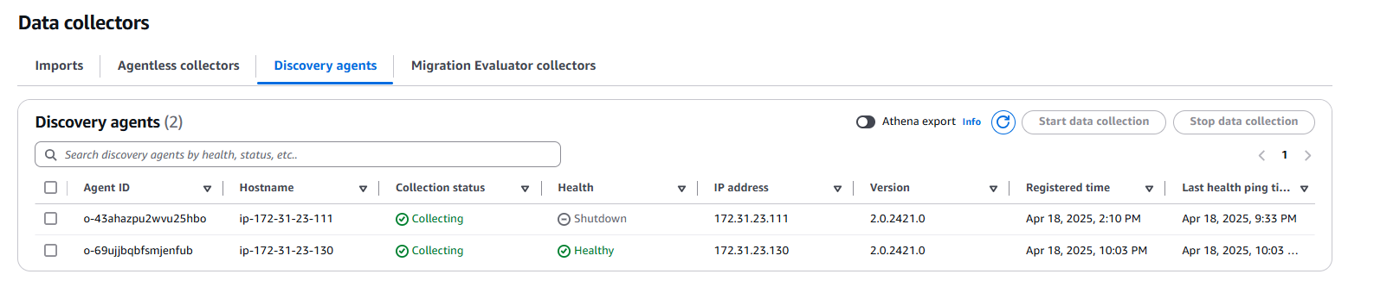
Evaluation of Discovered Application and Infrastructure Data
In this evaluation, we will review the analytic data from our servers to determine what Amazon Web Service product would be the recommended service to migrate to. The following will detail the processes captured on the server, what those processes are dependent on, and the performance metrics of the server. From the data collected from the data collector in AWS Discovery Service we will analyze the data. The analysis will be done by identifying the processes, mapping the dependencies and identifying the performance metrics. First, the following processes were seen running on the server: Apache HTTP Server, MySQL Database Server, SSH Daemon, AWS Discovery Agent and various system services. Second, the application dependencies are as follows: Apache HTTP Server depends on PHP, the PHP depends on MySQL Database, and SSH is needed for remote login. Third, the performance metrics are: CPU utilization: 0.57%, Disk usage: 0.0025 Kbps read, 0.69 Kbps write, Network I/O: 0.15 Kbps read, 0.25 Kbps write, Total disk space: 7.75 GB, 6.07 GB available, RAM: 2 GB total.
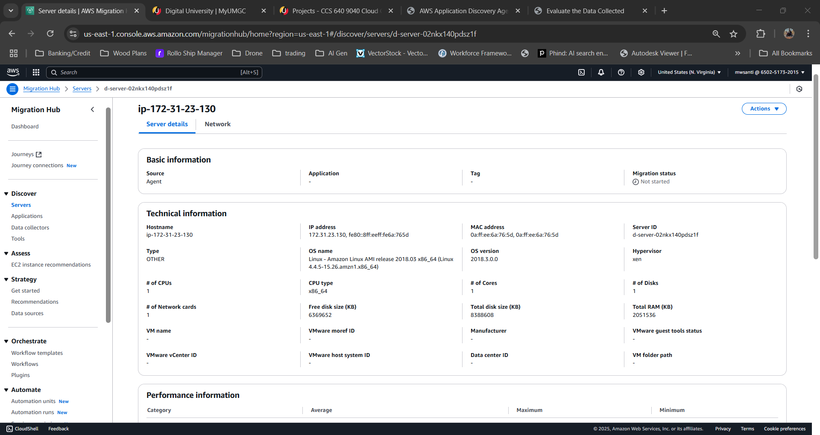

In our opinion for the migration of this BallotOnline system, we recommend AWS Elastic Beanstalk. This recommendation is due to Elastic Beanstalk ease of use and control. Amazon Web Services states, “Elastic Beanstalk reduces management complexity without restricting choice or control” (Amazon Web Services, n.d.). Elastic Beanstalk provides a straightforward deployment of existing applications by “automatically handl[ing] the details of capacity provisioning, load balancing, scaling, and application health monitoring” (Amazon Web Services, n.d.). The service will enable our applications to quickly migrate and initialize in a secure environment that will automatically scale when needed. This will reduce the workload on IT personnel during the migration but also still give our administrators the control needed to modify infrastructure during or later to meet BallotOnline requirements as we continue the migration process.
Migration Recommendations
The migration recommendation for BallotOnline is use the lift-and-shift strategy in order to move the servers from the on-premises data center to AWS Elastic Beanstalk. The lift and shift strategy is a part of the rehost method in AWS migration strategies (Amazon Web Services, 2025). The lift and shift strategy is defined as “mov[ing] your applications from your source environment to the AWS Cloud without making any changes to the application” (Amazon Web Services, 2025). This will be done by first, connecting BallotOnline data center with AWS Direct Connect in order to begin utilizing Aws resources and provide a stable network link for transfer. We will then install agent-based discovery on all our servers to determine various metrics and machine states. That information will be gathered into Migration Hub where when ready we will begin to transfer the data into AWS as a lift and shift strategy to ensure our applications and databases work properly on AWS. Based on testing we recommend moving our services to AWS Elastic Beanstalk because it provides a straightforward deployment of existing applications by “automatically handl[ing] the details of capacity provisioning, load balancing, scaling, and application health monitoring” (Amazon Web Services, n.d.). we also recommend Elastic Beanstalk because it “reduces management complexity without restricting choice or control” (Amazon Web Services, n.d.). Do to these factors we believe Elastic Beanstalk meets the requirements of BallotOnline policies, by maintaining encryption, IAM, auto-scaling, and employees are still able to maintain control and modify cloud infrastructure as needed.
Conclusion
In conclusion, the BallotOnline cloud migration plan will move our on premise servers to AWS cloud infrastructure in order to gain scalability and cost reduction. The migration is recommended to move our services to AWS Elastic Beanstalk. This plan will implement the lift and shift strategy from AWS to move our applications while not making any changes to the applications. This plan will use AWS Application Discovery Service agent-based collector in order to capture system configuration and performance data to ensure correct migration parameters. This migration plan provides BallotOnline with a secure migration to AWS cloud.

References
Amazon Web Services. (2016, JUN 24). 21 Best Practices for Your Cloud Migration. Retrieved from Amazon Web Services: https://aws.amazon.com/blogs/enterprise-strategy/21-best-practices-for-your-cloud-migration/
Amazon Web Services. (2025). AWS Application Discovery Service. Retrieved from Amazon Web Services: https://docs.aws.amazon.com/pdfs/application-discovery/latest/userguide/appdiscovery-ug.pdf
Amazon Web Services. (2025). AWS Prescriptive Guidance. Retrieved from Amazon Web Services: https://docs.aws.amazon.com/pdfs/prescriptive-guidance/latest/large-migration-guide/large-migration-guide.pdf
Amazon Web Services. (2025). What is AWS Application Discovery Service? Retrieved from Amazon Web Services: https://docs.aws.amazon.com/application-discovery/latest/userguide/what-is-appdiscovery.html
Amazon Web Services. (2025). What is Data Migration? Retrieved from Amazon Web Services: https://aws.amazon.com/what-is/data-migration/
Amazon Web Services. (n.d.). What is AWS Elastic Beanstalk? Retrieved from Amazon Web Services: https://docs.aws.amazon.com/elasticbeanstalk/latest/dg/Welcome.html
Azure. (2024, SEP 26). Azure Migrate documentation. Retrieved from Azure: https://learn.microsoft.com/pdf?url=https%3A%2F%2Flearn.microsoft.com%2Fen-us%2Fazure%2Fmigrate%2Ftoc.json
NetApp. (2022, DEC 20). How Insight is used by administrators, managers, and planners. Retrieved from NetApp: https://docs.netapp.com/us-en/oncommand-insight/overview/insight-for-administrators-and-planners.html
NetApp. (2022, DEC 20). OnCommand Insight overview. Retrieved from NetApp: https://docs.netapp.com/us-en/oncommand-insight/overview/oncommand-insight-overview.html
NetApp. (2024, OCT 24). OnCommand Insight documentation. Retrieved from NetApp: https://docs.netapp.com/us-en/oncommand-insight/pdfs/fullsite-sidebar/OnCommand_Insight_documentation.pdf

